Consistency / Cross-Field Check

Definition
# Source: AI Source: Provided by: [Data Path: Persons Table -> ID Column: 1, Name_En Column: Motasem Essam] -> From: [Chatgpt (GPT‑5 Mini)] on [12/10/2025]
Consistency or Cross-Field Check ensures that data across different fields, records, or tables do not conflict and follow logical rules.
- It prevents contradictory or incompatible information from entering the system.
- Commonly applied to related fields, linked tables, or sequential data.
Key idea:
It’s like verifying that a student’s date of birth matches the age or that a payment date is not before an invoice date.

Characteristics
# Source: AI Source: Provided by: [Data Path: Persons Table -> ID Column: 1, Name_En Column: Motasem Essam] -> From: [Chatgpt (GPT‑5 Mini)] on [12/10/2025]
- Validates relationship and coherence between data points rather than single values.
- Often used in databases, spreadsheets, and multi-field forms.
- Helps maintain logical integrity and reliability of data.
- Can detect human entry errors, duplicate entries, or conflicting records.

Examples
# Source: AI Source: Provided by: [Data Path: Persons Table -> ID Column: 1, Name_En Column: Motasem Essam] -> From: [Chatgpt (GPT‑5 Mini)] on [12/10/2025]
- Student Age vs. Date of Birth
- Date of Birth: 2010-05-15
- Age entered: 12 ✅ (consistent)
- Age entered: 20 ❌ (inconsistent)
- Invoice vs. Payment Date
- Invoice Date: 01-Jan-2026
- Payment Date: 05-Jan-2026 ✅ (consistent)
- Payment Date: 30-Dec-2025 ❌ (inconsistent)
- Course Enrollment vs. Grade
- Course: Math101
- Grade: A+ ✅ (consistent if student enrolled)
- Grade: B ❌ (inconsistent if student not enrolled)
- Address vs. Postal Code
- City: Cairo
- Postal Code: 10001 ✅ (matches)
- Postal Code: 90210 ❌ (does not match city)

Advantages
# Source: AI Source: Provided by: [Data Path: Persons Table -> ID Column: 1, Name_En Column: Motasem Essam] -> From: [Chatgpt (GPT‑5 Mini)] on [12/10/2025]
- Detects contradictory or illogical data across records.
- Improves overall data integrity and reliability.
- Supports accurate reporting, analysis, and decision-making.
- Useful in multi-field forms, linked tables, or cross-system checks.

Disadvantages
# Source: AI Source: Provided by: [Data Path: Persons Table -> ID Column: 1, Name_En Column: Motasem Essam] -> From: [Chatgpt (GPT‑5 Mini)] on [12/10/2025]
- Cannot detect incorrect data that is internally consistent (e.g., wrong age that matches a wrong DOB).
- Requires well-defined relationships to check against.
- May reject valid data if rules are too strict or incomplete.

Example Section
# Source: AI Source: Provided by: [Data Path: Persons Table -> ID Column: 1, Name_En Column: Motasem Essam] -> From: [Chatgpt (GPT‑5 Mini)] on [12/10/2025]
A school database has student records:
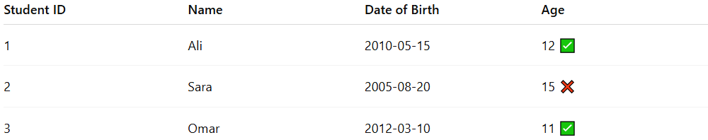
Student ID | Name | Date of Birth | Age
1 | Ali | 2010-05-15 | 12 ✅
2 | Sara | 2005-08-20 | 15 ❌
3 | Omar | 2012-03-10 | 11 ✅
- Sara’s age is inconsistent with her date of birth (should be 20).
- The system flags the record for review before storing it.

If you want, I can continue with Validation Check 4: Presence Check in the same detailed format so you’ll have a complete list of validation checks.
Do you want me to do that?

